**12/10/2021 CD SPOT 6 2019103573**

**SPOT – EXERCISE**

**1.Write a lex program to convert the following while statement to for statement.**

**while(condition) {**

**statement(s);**

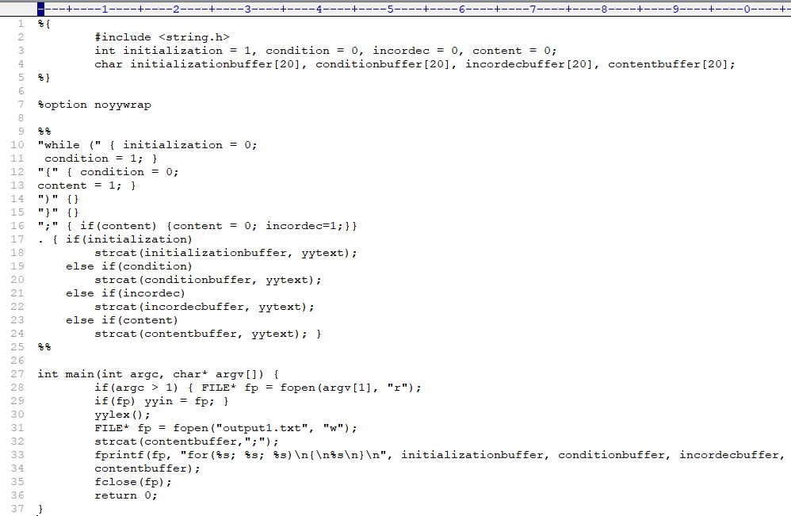 **}**

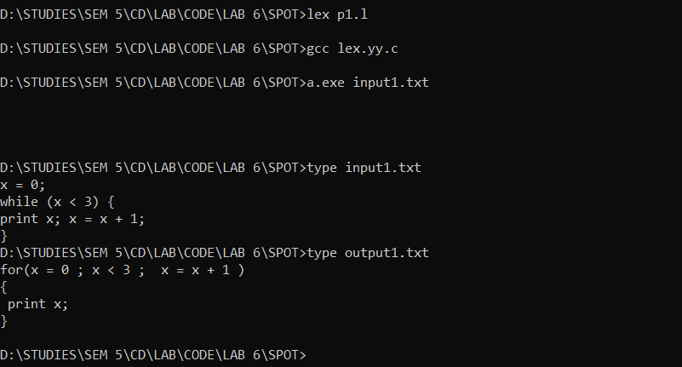

**OUTPUT :-**

**2.Write a lex program to convert if-else statement to switch-case statement.**

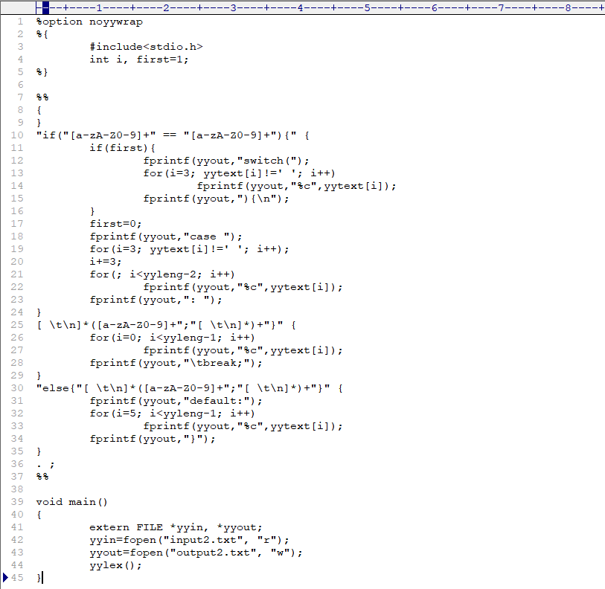**CODE :-**

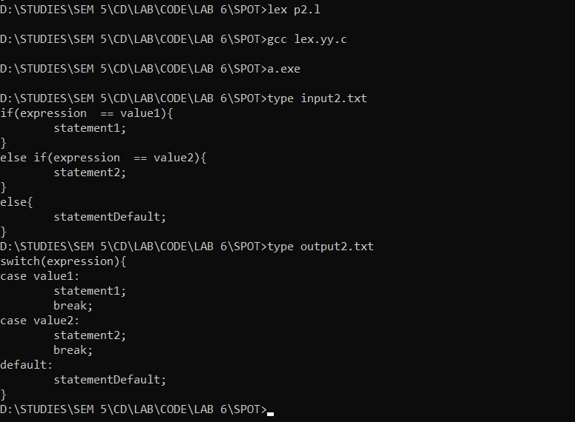**OUTPUT :-**